1. Windows 7 or earlier PC system version click 32install.exe/64install.exe to install usb driver directly.

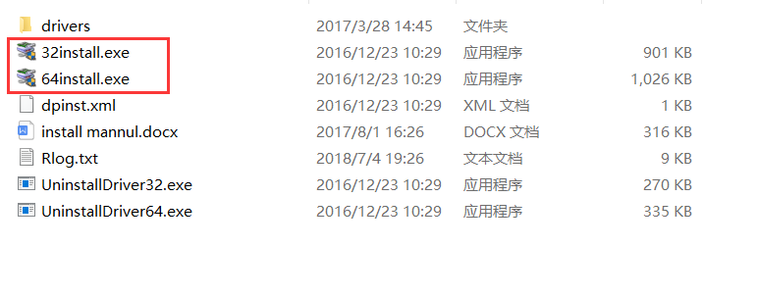

Select the install file according to your system bits(32 or 64).

1. Windows 10 or Windows 8

**Notice: Close all running application before start the follow operation.**

<1> Click Windows Menu-----> Setting

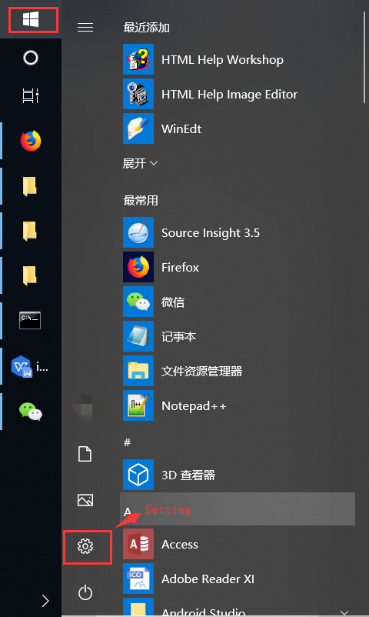

<2> Click Update and Security

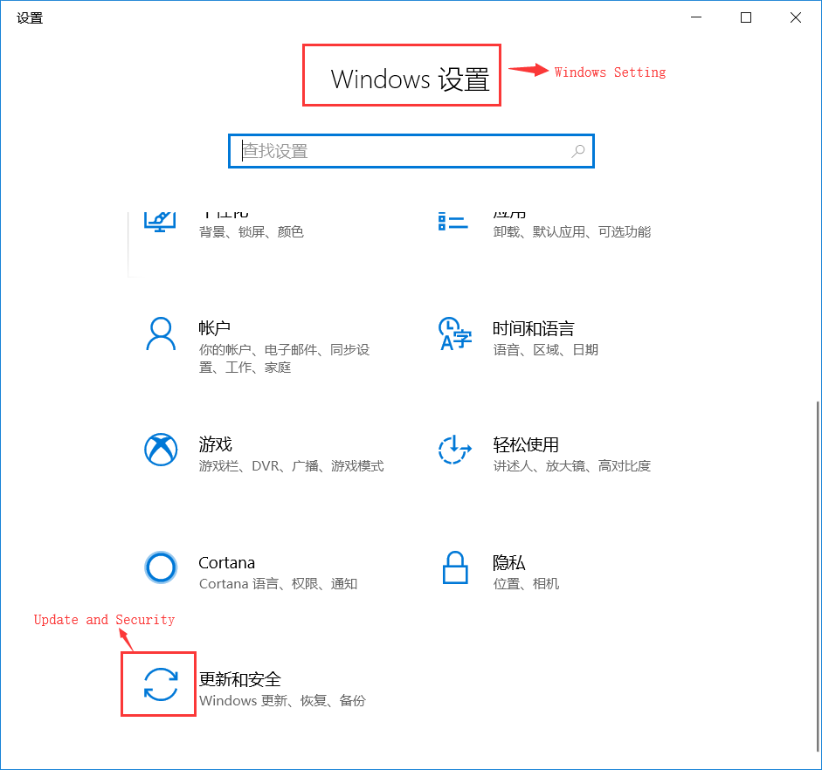

<3> Select [Recovery and Click Reboot Now].

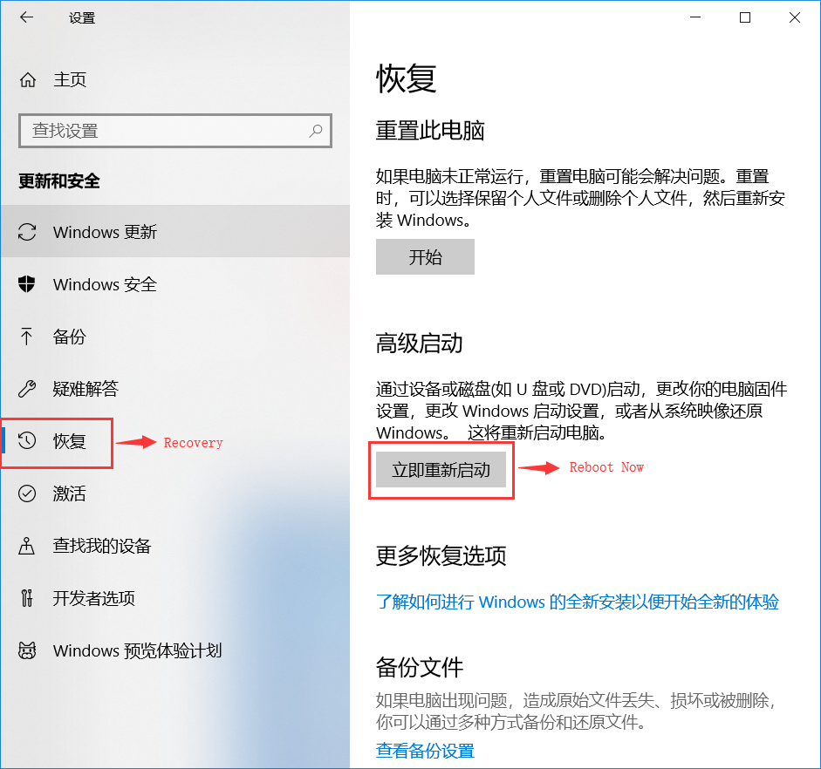

<4> Select [Problem Solution].

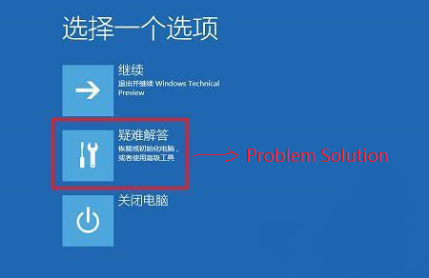

<5> Click [Advanced Options].

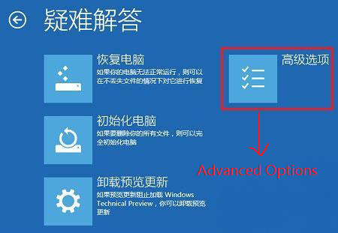

**<6> Click [Start Setting].**

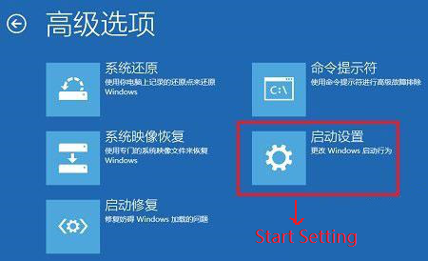

<7> Find and Click [Reboot] in Start Setting Menu.

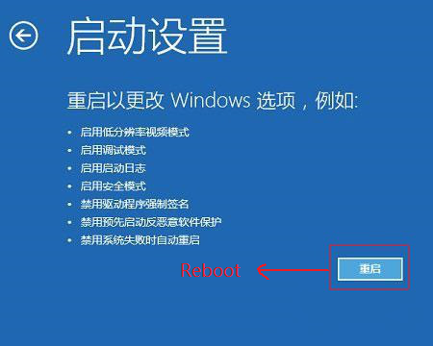

<8> Press key [7] or [F7] to select [Disable dirver mandatory signature] in [Start Setting] menu after PC reboot again.

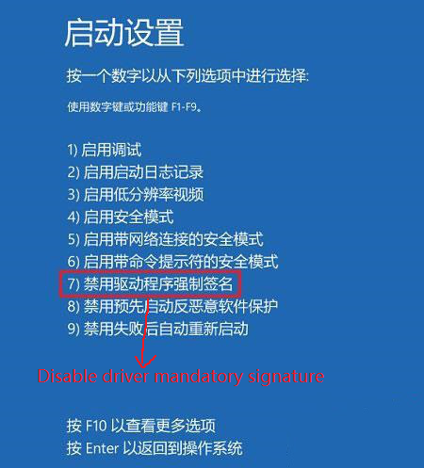

<9> Wait for installing finish after clicking 64install.exe.

